CSE520
Samuel Marrujo
Professor Yu
Lab 05

Draw a rotating tetrahedron with Android

In this lab, we are to create 2 buttons and show images from the buttons as they are pressed using the Eclipse IDE. I have successfully completed this task, and here is a picture of the following:

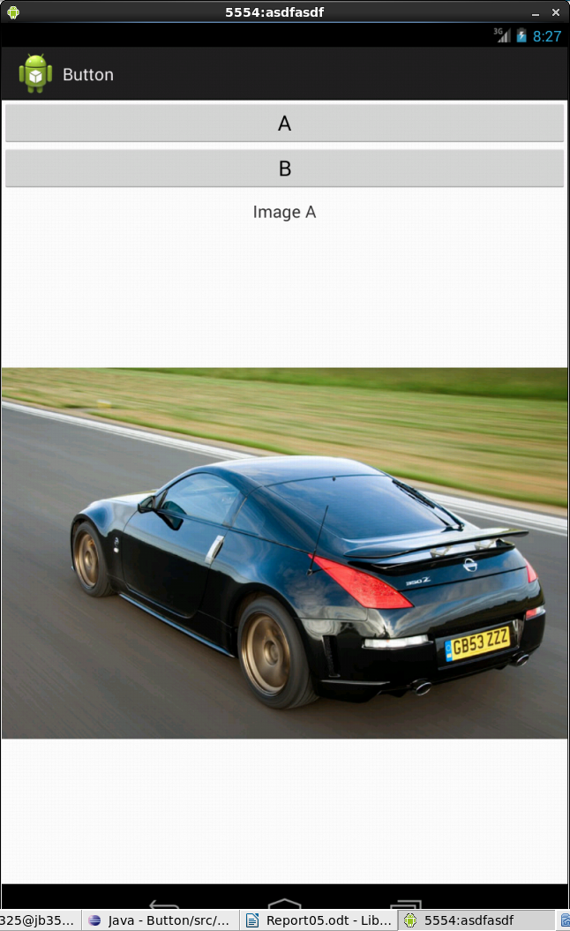
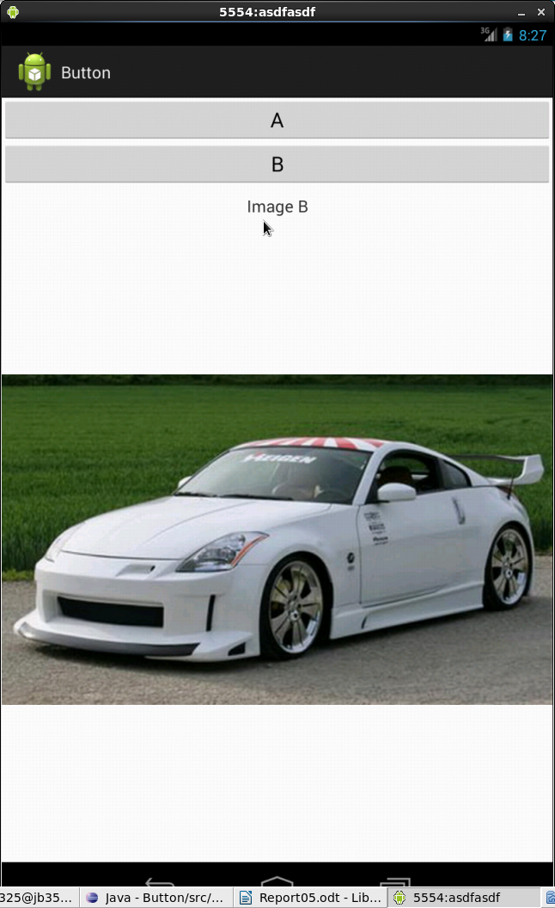
Main Activity Code:

package opengl.button;

import android.view.View.OnClickListener;
import android.widget.ImageView;
import android.widget.TextView;
import android.widget.Button;
import android.graphics.Bitmap;
import android.graphics.BitmapFactory;
import opengl.button.R;
import android.app.Activity;
import android.os.Bundle;
import android.view.View;

public class MainActivity extends Activity {
Button imageButton;
Button imageButton2;
Bitmap bitmap;
Bitmap bitmap2;
ImageView image;
TextView message;

@Override
public void onCreate(Bundle savedInstanceState) {
super.onCreate(savedInstanceState);
setContentView(R.layout.activity_main);
bitmap = BitmapFactory.decodeResource(this.getResources(), R.drawable.picture);
bitmap2 = BitmapFactory.decodeResource(this.getResources(), R.drawable.picture2);
addListenerOnButton();
}
//define Listeners
public void addListenerOnButton() {
imageButton = (Button) findViewById(R.id.imageButton1);
imageButton2 = (Button) findViewById(R.id.imageButton2);

imageButton.setOnClickListener(new OnClickListener() {
@Override
public void onClick(View view) {
message = (TextView) findViewById(R.id.message);
image = (ImageView) findViewById(R.id.carimage);
message.setText("Image A");
image.setImageBitmap(bitmap);
}
});

imageButton2.setOnClickListener(new OnClickListener() {
@Override
public void onClick(View view) {
message = (TextView) findViewById(R.id.message);
image = (ImageView) findViewById(R.id.carimage);
message.setText("Image B");
image.setImageBitmap(bitmap2);
}
});
}
}

activity_main Code:

<?xml version="1.0" encoding="utf-8"?>
<LinearLayout xmlns:android=
"http://schemas.android.com/apk/res/android"
android:layout_width="fill_parent"
android:layout_height="fill_parent"
android:orientation="vertical" >

<Button
android:id="@+id/imageButton1"
android:layout_width="match_parent"
android:layout_height="wrap_content"
android:text="A"
android:textSize="10pt" >
</Button>
<Button
android:id="@+id/imageButton2"
android:layout_height="wrap_content"
android:layout_width="match_parent"
android:text="B"
android:textSize="10pt" >
</Button>
<TextView
android:layout_height="wrap_content"
android:layout_width="match_parent"
android:layout_marginLeft="6pt"
android:layout_marginRight="6pt"
android:textSize="8pt"
android:layout_marginTop="4pt"
android:id="@+id/message"
android:gravity="center_horizontal">
</TextView>
<ImageView
android:layout_height="fill_parent"
android:layout_width="fill_parent"
android:id="@+id/carimage">
</ImageView>

</LinearLayout>

